

Midterm Evaluation: 30%

|  |  |
| --- | --- |
| **Course Identification** | |
|  |  |
| Name of program – Codes: | COMPUTER SCIENCE TECHNOLOGY - SPECIALIZATION IN ADMINISTRATIVE DATA PROCESSING – 420.AA |
| Course title: | **Android Mobile** |
| Course number: | 420-DA4-AS |
| Group: | 07384 |
| Teacher’s name: | Alex Sandro Steinheuser Vilvert |
| Duration: | 4 periods (210 minutes) |
| Semester: | Fall 2021 |
| **Student Identification** | |
| Name: **Mohammed Waseq Rahman** Student number: **1913864**  Date: **19th October,2021** Result: ______________  I declare that this is an original work, and that I credited all content sources of which I am not the author (online and printed, images, graphics, films, etc.), in the required quotation and citation style for this work. | |
| **Standard of the Evaluated Competencies** | |
|  | |
| **-** Make functional improvements to an application - 0176   | ***Evaluated elements of the competency*** | | ***Relevant performance criteria specific to each element*** | | | --- | --- | --- | --- | | 3. Add functions to an application and modify them. | | 3.1 Realistic planning of key activities.  3.2 Development and modification of appropriate  algorithms.  3.3 Correct design and modification of appropriate  data structures.  3.4 Correct installation of data structures.  3.5 Appropriate conversion of existing data.  3.6 Correct production and modification of the  appropriate graphics interfaces.  3.7 Proper programming of new functions.  3.8 Appropriate modification of the programs  affected by the changes.  Proper use of existing resources. | | |  | |   **Conditions for the Completion of a Sole Course, or the Last Course within a Sequence of Courses, to Develop a Competency**  A sole course to develop a competency, or the last course within a sequence of courses, to develop a competency, can only be completed if the student meets the following two conditions:   * Receive a cumulative grade, including the final evaluation, greater than or equal to 60%. * Obtain a grade higher than or equal to 60% for the final evaluation.   Essentially, the failure of the final evaluation results in the failure of this course; even if the student’s cumulative grade, including the final evaluation, is greater than 59%. In such a case and when the evaluation constitutes an exam, the student has the right to take a supplemental evaluation. However, when the evaluation constitutes a project (the whole process or part of it outside of the classroom), the student may request a revision of his/her final grade as stipulated by Article 5.19 of the Institutional Policy on Evaluating Learning (IPEL).   |  | | --- | | **Instructions** | |  | | Permitted equipment: CalculatorClass notes are not allowed and students may not use the dictionary.No break is allowed during this exam. Students are not allowed to exit the examination room before half of the allotted time has passed. Once a student has exited the classroom, he/she may not re-enter (IPEL – Article 5.12.4).The teacher will not answer questions during the exam.Students must remain silent during the exam.It is the teacher’s responsibility to identify language errors. If such errors are found, teachers may deduct up to 20% of the final grade (IPEL – Article 5.7).Plagiarism, attempts at plagiarism or complicity in plagiarism during a summative evaluation results in a mark of zero (0). In the case of recidivism, in the same course or in another course, the student will be given a grade of '0' for the course in question.(IPEL – Article 5.16).Please write clearly. | | |
|  | |
|  | |
| **Mark Breakdown** | |
|  | |
| This evaluation is worth 100 points, distributed as follows:  **TOTAL : 100 POINTS** | |

**Exercise 01 : Asnwer the Concept Questions Below (10 points)**

**Question 1: (10 pts)**

With your own words, define MVC concept.

**MVC stands for Model-View-Controller. It is basically a 3-layer process of making an application. The Model is the part which takes care of the data. It can be a database for example. The View is the user interface consisting of buttons, textboxes etc. which builds up a window or screen which can be interacted with. Practically known as the front end of an application and what the user sees. Lastly, the controller is what’s responsible for user input. Whatever input is taken, the controller takes care of it which ends up updating the view and the model. These 3 parts make up an application or software and in Computer terms, known as MVC.**

**Exercise 02 : Android Appplication Convertion (90 points)**

Develop one Android Application that will have 3 Activities (main, Temperature, Metrix).

# Setup the Environnement (10 min):

1. Create a **folder Exam** on your C:\android\repository.
2. Create new project with empty Activity.
3. Save the new project with this name: **YourNumberID_YourName_Android_Midterm**
4. Use can decide to use Linear Layout or Constraint Layout.

**Question 1: Create and setup the Resources Style and activities according to the images below (45 pts)**

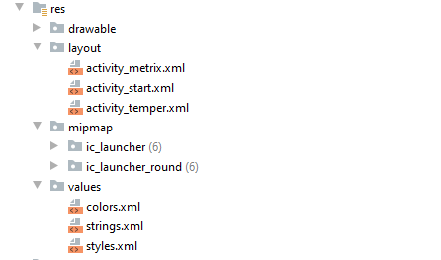

**Activity_Start:**

Create the main activity to when press the Temperature button move to **Activity_Temper**, when press Metrix Button move to **Activity_Metrix** and when press End Button. Do not forget the use the styles.

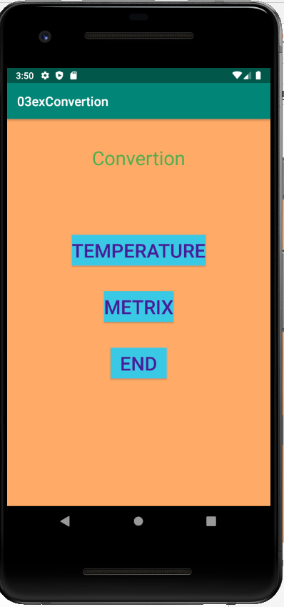

**Activity_Temper:**

Insert temperature in Celsius and when press the button convertion shows an event toast with the value converted to Farenheit. When press the button return, bring back the application to the Activity_Start. Do not forget the use the styles.

## Celsius to Fahrenheit formula

°F =°C * 1.8 + 32.00

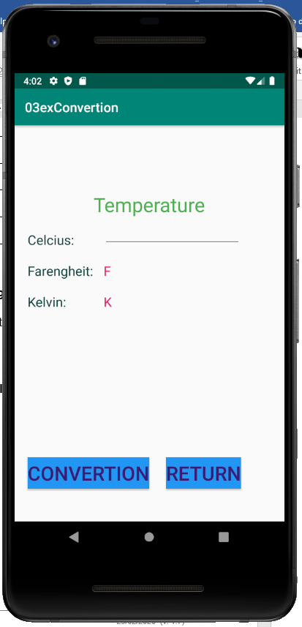

**Activity_Metrix:**

Insert the distance in Kilometers and when press the button convertion shows an event toast with the value converted to Meters. When press the button return, bring back the application to the Activity_Start. Do not forget the use the styles.

## Kilometer to Meter formula

m = K / 0.001

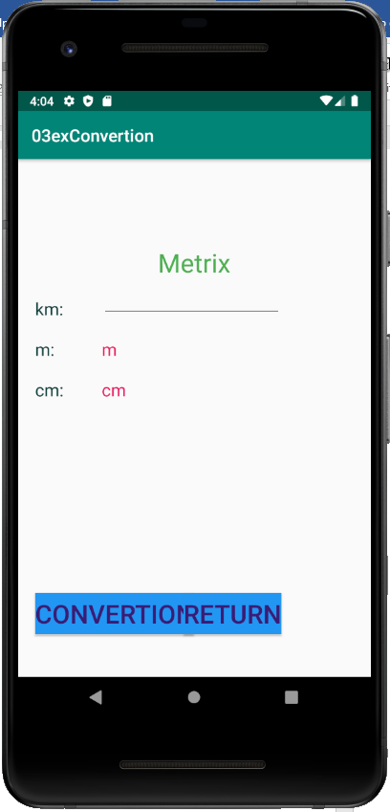

**Question 2: Create the logic (model) and controller for the requirements of question 1 (45 pts)**

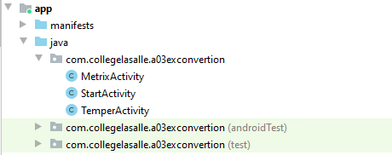

|  |  |  |  |  |  |  |  |  |  |  |  |  |  |  |  |  |  |  |  |  |  |  |  |  |  |  |  |  |  |  |  |  |
| --- | --- | --- | --- | --- | --- | --- | --- | --- | --- | --- | --- | --- | --- | --- | --- | --- | --- | --- | --- | --- | --- | --- | --- | --- | --- | --- | --- | --- | --- | --- | --- | --- |
| **CORRECTION GRID FOR LANGUAGE**   |  |  |  |  | | --- | --- | --- | --- | | Clear Communication | Clear Communication, **most of the time** | Vague Communication | Unclear Communication | | - 0 | - 0,5 | - 1,5 | - 2 | | (Word Choice)  Use of precise and rich vocabulary | (Word Choice)  Use of precise vocabulary | (Word Choice)  Use of imprecise vocabulary | (Word Choice)  Use of inappropriate vocabulary | | - 0 | - 0,5 | - 1,5 | - 2 | | (Format/Type of work)  Respect of norms | (Format/Type of work)  Respect of **most of the** norms | (Format/Type of work)  Non-respect of the norms | (Format/Type of work)  Inappropriate in relation to the required norms | | - 0 | - 0,5 | - 1,5 | - 2 | | (Linguistic Code)  (≤2 mistakes / page) | (Linguistic Code)  (3-7 mistakes/page) | (Linguistic Code)  (8-10 mistakes/ page) | (Linguistic Code)  (>10 mistakes/  page) | | - 0 | - 0,5 - 2.5 | - 2.5 - 3.5 | - 4 | |